WAGE Competency Curriculum Guide

WAGE Competency M18: Reading numbers or symbols from time, weight, distance, and volume measuring scales.

NOTE: You will need to collect two additional documents that are similar in nature to the one provided in this lesson at Hook 1a. These should be collected from local employers that support your program. These two additional documents will be used in Hooks 2 and 3 and are not to be duplicates of the other two documents used in this lesson. DO NOT USE MATERIALS THAT ARE NOT RELEVANT TO THE WORKPLACE.

Hook 1a
Project an overhead transparency of the bus schedule. Say, “Let’s pretend you work for a local company and you helping a new employee read the bus schedule so she will know what bus to catch. What are the thinking steps that you would want her to use as she looks at the schedule? What is the first thing that should be done? The second, and so on?”
Record all responses on a flip chart and save for later use.
Coach students during a brainstorming activity but do not offer suggestions.

Bridge
Acknowledge the responses offered; question students further to generate additional responses.
Ask, “Do you believe that these are the only thinking steps that should be used?” Pause. “Could there be more?”
Say, “Now we are going to go to our lessons and list the thinking steps we should know and use. When we have finished our work, we will compare your answers that I have recorded on the flip chart to the ones we have learned.”
Book
Select a lesson (or lessons) from the wage curriculum Matrix or other source that best supports your needs. Spend ample time in the chosen lessons until you believe that each learner has mastered the skill. As you move through each lesson, be sure to emphasize the thinking steps that a learner must use to correctly apply this skill. Ensure that all thinking steps are properly sequenced during the learning and that each learner has had opportunities to practice each step in the application of the skill. Write the thinking steps identified by the lesson(s) in the sequential order they are to be used; you will use these again in Hooks 1b, 2, and 3.
Use the Bus Schedule transparency and Reading Time – Weight – Distance – Volume.
Thinking Steps for Competency M18.
NOTE: If your chosen lesson(s) indicates a different set of thinking than these listed here, substitute those that was presented in the lesson(s).
- Know what needs to be measured.
- Be familiar with the different numbers and symbols of measurement.
- Measure the object and read the amount with accuracy.

Hook 1b
Get out the Bus Schedule transparency, Reading Time – Weight – Distance – Volume, and the sheet of paper where you recorded learner responses in Hook 1a.
Say, “We are going to evaluate your answers. You gave me the following steps.” Post the sheet with responses on the wall. “Now, let’s look at the thinking steps that the lessons recommended we use.” Compare their responses to the given recommendations.
Example: Use the Bus Schedule transparency to create a scenario in which the learner will visualize the situation and the need to learn the skills for this competency.
Say, “Now I am going to model for you the use of the thinking steps we learned as I follow the direction to complete this task. As I say the thinking step, you help me apply the skill at each step. Do you understand what we are going to do?” Address any concerns before moving ahead. Call out each thinking step and get the learners to assist you as you perform the task at each step.

Hook 2
Say, “Now that I have modeled how a new worker would use the thinking steps we learned when performing this task, are there any questions before you complete two more assignments?” Address all concerns before moving ahead.
Hand out a copy of Completing a Mileage Log that you have chosen for this exercise to each student.
Say, “Here is another assignment that uses measurements. In this exercise, I want you to work alone and use the thinking steps you learned as you complete this task. When you have all finished, each of you will have a chance to model for the class the thinking steps we should use as we complete this task. I will ask you to model the steps for the class and tell us what we should do as we go through each step. Are there any questions about your task?” Address all concerns before moving ahead.
When all have finished, ask for a volunteer to model the application of thinking steps to the task. Pay attention to the proper sequence, the learner’s ability to model, and the actions that must take place at each step. Allow all who want to model the steps an opportunity to do so before moving ahead. Have the students turn in all work to you. Review the work and address any exceptions noted with the learner.
NOTE: Mastery of this competency is determined by the students’ work on Hook 2. Review or rework is necessary when a student has not demonstrated mastery at Hook 2. Mastery is defined as the task being performed correctly with zero mistakes. A WAGE certificate should not be granted without mastery on all competencies listed in the student’s Individualized Program Plan.

Hook 3
Compliment the class for all the good work done at Hook 2. Say, “For this last exercise, you will work in teams, like they do at the workplace. In the workplace, workers know that people who are working together usually do the best work. By working together, they are able to combine their skills, share in the work, and complete the job in the proper amount of time.
“Now, I want you to move into teams of at least three people and no more than five people. Your team will need a leader, so select a leader now.” Make note of the leader in each team. Try to see that all learners have an opportunity to serve as leader during the course of their study.
Hand out the third assignment, Group Work for Competency M18, selected for this exercise. Be sure to give only one copy to each team. Say, “Team leaders, I want you to assign the thinking steps to each member of your team. If there are more steps than members, give each member more than one step. Try your best to make your distribution of thinking steps as fair as possible.”
Say, “Working as a team, I want you to apply the thinking steps we learned to the task. Each of you will be doing a different step, so make sure to keep up with your work and your solutions. When all of your team members have completed their assignments, the team leader is to put all the work together into a completed task. Team leaders, you will present your team’s model of this task to the other teams in this class. Are there any questions?” Address all concerns before moving ahead.
When all the teams are finished, call for a volunteer leader to model the application of thinking steps to this task. Get the other teams to offer constructive criticism when appropriate. Strive to develop a level of competitiveness between teams. This will increase the bonds between team members and make the learning more fun. You might work up a recognition system for rewarding good work by each team. Be careful that your students do not get in the same team with each lesson.
NOTE: When it is impossible to use teams at Hook 3, usually due to an open-entry, open-exit class format, you will want to use peer tutors, paraprofessionals, or yourself as a supplement to the team. When conducted correctly, the concepts of interdependence can be reinforced when there are only two people assigned to the task.

Evaluation for M18:
85% on all worksheets
95% on Assessment for Competency M18

Resource Listing for M18:
Lassiter, Karen. Math Skills for the Workforce: Measurement, Geometry, and Algebra. Austin: Steck-Vaughn Company. 1997.
Mitchell, Robert. Math Skills That Work: A Functional Approach for Life and Work: Book One. Chicago: Contemporary Books. 1991.

Bus Schedule

 |  | 3 | 4 |  |  |  | 5
 | a | BUS LEAVES  From  Signal Plaza | Bus Arrives at  Alexian  Brothers | Does bus go on Signal Mtn. Rd.  Or US 27? |  | Does bus serve Provident Loop? | BUS ENDS at Broad St. & 12th St. | Bus goes on to serve Route: | Bus Arrives At CARTA Garage:
WEEKDAYS
A.M. |  | 7:00 | 7:10 |  | US 27 | YES | 7:40 | #14 | −
 |  | 8:20 | 8:35 |  | Signal Mtn | no | 9:05 | #28B | 9:40
 |  | 8:40 | b 8:50 |  | Signal Mtn | no | 9:20 | #14 | −
 |  | 9:55 | 10:05 |  | Signal Mtn | no | 10:30 | − | c 10:40
P.M. |  | 2:35 | 2:45 |  | Signal Mtn. | no | 3:15 | #14 | −
 |  | 3:55 | 4:15 |  | Signal Mtn | YES | 4:50 | #14 | −
 |  | 5:20 | 5:30 |  | Signal Mtn | no | 6:00 | − | 6:10

Reading Time – Weight – Distance – Volume
In the workplace we are faced with reading various measurements. Accuracy in reading these amounts is important in getting our jobs done right. This lesson will focus on the numbers and symbols of four measurements – time, weight, distance and volume.

Time
Time is a valuable commodity and there is never enough of it! Reading time is used when we want to know when the next bus is coming or our favorite television show is on. At work we read time to know when to come to work and to leave. Our paychecks show the hours that we worked.

Measures of Time
1 minute (min.) = 60 seconds (sec.)
1 hour (hr) = 60 minutes
1 day = 24 hours
1 week (wk.) = 7 days
1 year (yr.) = 52 weeks
1 year = 12 months (mo.)

The common units for measuring time are seconds, minutes, hours, days, weeks, months, and years. It takes about a second to say “one”, a minute to watch two TV commercials, and about two hours to watch a movie.

Reading a 12-hour Clock

Reading a clock is something most of us do each day. The clock keeps track of the minutes and hours of the day.
- The shorter hand of the clock represents one-hour.
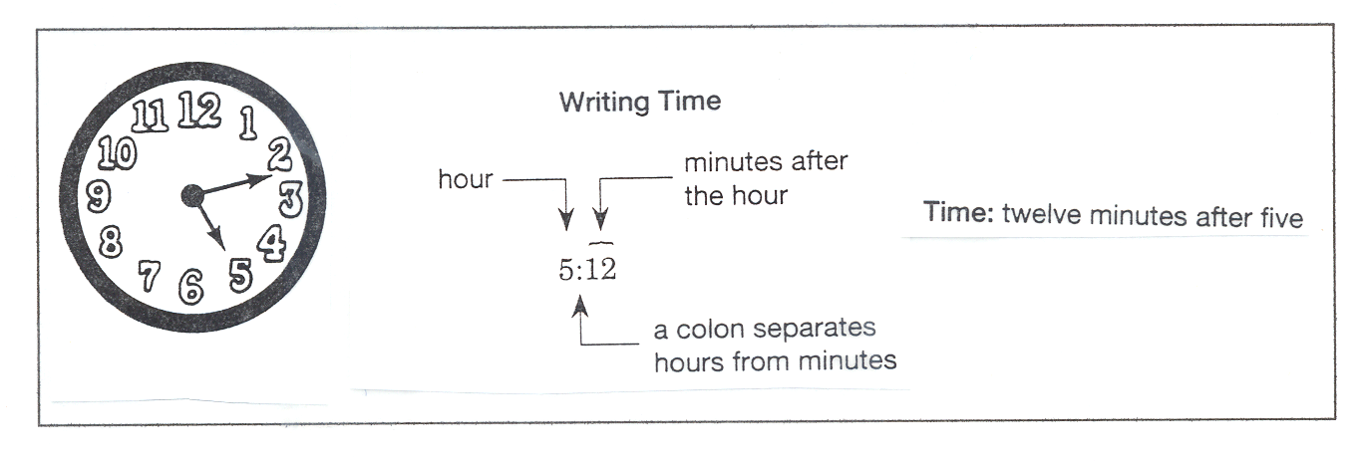
- The longer hand of the clock is the minute hand and each number on the clock face represents five minutes. To get around the clock you count by fives.
Weight
Measuring weight is a part of our daily lives. Who hasn’t gotten on a scale to check out the extra pounds? When you go to the grocery store you weigh produce to see what it will cost you. Postal workers weigh packages to decide how much postage is needed for shipping. Deli clerks fill an order for 2 pounds of lunchmeat. Truck drivers pull into a truck weighing station to have a truckload weighed. Many jobs use weight measurement.

Weight measures how heavy something is. You can weigh solid objects, liquids, and dry goods. The common units for measuring weight are ounces, pounds and tons.

Measures of Weight
1 pound (lb) = 16 ounces (oz.)
1 ton (T.) = 2,000 lbs.
Scales are used to measure how much an object weighs. Scales show weight in pounds and fractions of a pound: halves, fourths, eights, and sixteenths. Some scales show weight in ounces and half-ounces. Scales at the post office measure by ounces. To read this kind of scale, read down from zero. Find the nearest whole ounce before the arrow. Then find the fraction of an ounce the arrow is pointing to. The total amount an item weighs is read as a whole or mixed number.

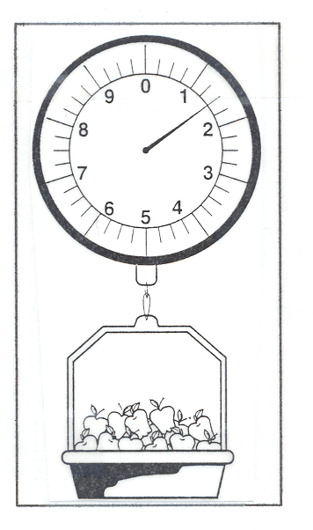
To read a scale marked with pounds and fractions of a pound find the nearest whole pound before the arrow shown on the scale. Then find the fractions of a pound that the arrow is pointing to. The total amount is read as a whole or mixed number such as 4 pounds or 4 ¼ pounds.

Scales can be electronic or manual and show either English or metric weight. A scale has lines or marks called increments that represent a specific number. Scales measure large weight or small weight. When you use a scale identify what measurement units are being used (1 ton = 2,000 pounds, 1 pound = 16 ounces, 1 ounce = 437.5 grains). Then check if the scale is at “0” before you start to measure.

Look at the scale. If there are 16 ounces in each pound, how many ounces does each increment represent? _____________________
How much do the apples weigh? _____________________

Distance

Distance is the length between two points or objects. Length is measured by inches, feet yards, and miles. These units measure width, depth, height and distance.

Rulers are used to measure length. English standard rulers are divided into inches and fractions of an inch: halves, fourths, eighths, and sixteenths. Metric rulers are divided into centimeters and millimeters. When reading a ruler, it is easier to read from left to right.

Measure of Length
1 foot (ft. or ‘) = 12 inches (in. or “)
1 yard (yd.) = 36 inches
1 yard = 3 feet
1 mile (mi.) = 5, 280 feet
1 mile = 1, 750 yards

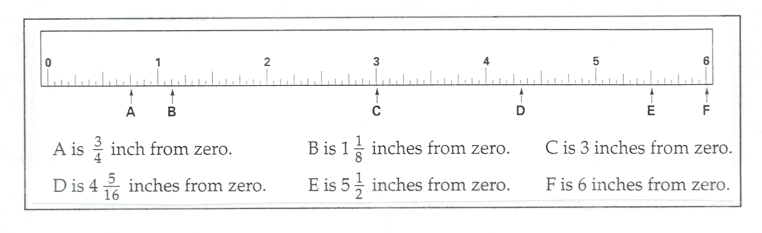

Reading an Odometer
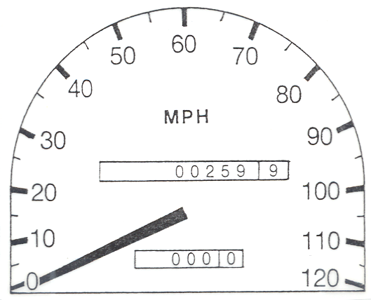
If you travel on the job it is often necessary to fill out a travel log in order to get reimbursed for your fuel expenses. You measure the distance you travel by using an odometer or instrument to measure distance traveled by a vehicle.

In the odometer shown here, the car’s mileage is 259.9 miles. The number in the white box (9) shows the tenths of a mile. The number reads: two hundred fifty-nine and nine-tenths of a mile.

Let’s say you are a pizza delivery person. At the beginning of the day your odometer reads:

13220 | 8

At the end of the day it reads:
13263 | 3

What is your mileage for the day? _____________________

Volume

Volume is the amount of space an object takes up. When you measure volume you are measuring the capacity of the object. Units for measuring capacity are fluid ounces, cups, pints, quarts, and gallons.

Measures of Capacity
1 cup (c.) = 8 fluid ounces (fl. oz.)
1 pint (pt) = 2 cups
1 quart (qt.) = 4 cups
1 quart = 2 pints
1 gallon (gal.) = 4 quarts

Some measuring cups have two scales of measure. One is marked with cups and fractions of a cup to measure either liquid or dry ingredients. The other is marked with cups and fluid ounces to measure only liquids.
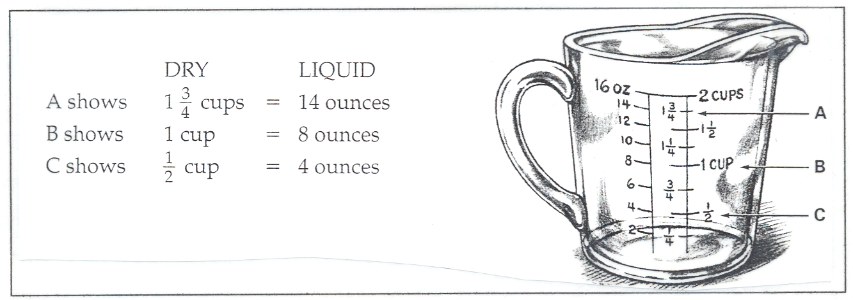

Some measuring cups show teaspoon and tablespoon.

1 tablespoon (tbsp.) = 3 teaspoons (tsp)
1 tablespoon = ½ fluid ounce (fl. oz.)
1 tablespoons = 1 fluid ounce

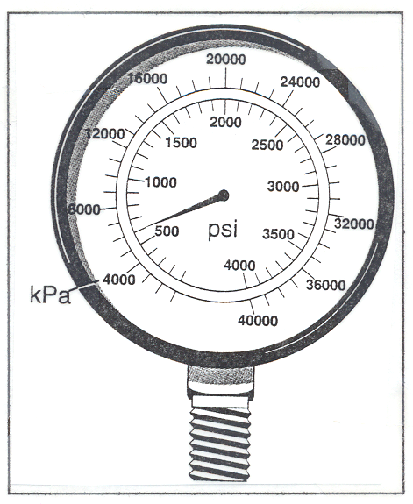
For measuring liquids or gases that are held in tanks you would use a gauge to indicate amount. Air, water, steam, and gases (like helium) are measured in psi (pounds per square inch) or kPa (kiloPascal). Just like with a scale, a gauge measures in increments.

Study the pressure gauge shown. It indicates the levels for nitrous oxide.

If the tank falls below 500 psi, you call for a replacement.

Do you need to call for a replacement? ________________

Practice

Let’s practice time and distance by using a bus schedule.
 |  | 3 | 4 |  |  |  | 5
 | a | BUS LEAVES  From  Signal Plaza | Bus Arrives at  Alexian  Brothers | Does bus go on Signal Mtn. Rd.  Or US 27? |  | Does bus serve Provident Loop? | BUS ENDS at Broad St. & 12th St. | Bus goes on to serve Route: | Bus Arrives At CARTA Garage:
WEEKDAYS
A.M. |  | 7:00 | 7:10 |  | US 27 | YES | 7:40 | #14 | −
 |  | 8:20 | 8:35 |  | Signal Mtn | no | 9:05 | #28B | 9:40
 |  | 8:40 | b 8:50 |  | Signal Mtn | no | 9:20 | #14 | −
 |  | 9:55 | 10:05 |  | Signal Mtn | no | 10:30 | − | c 10:40
P.M. |  | 2:35 | 2:45 |  | Signal Mtn. | no | 3:15 | #14 | −
 |  | 3:55 | 4:15 |  | Signal Mtn | YES | 4:50 | #14 | −
 |  | 5:20 | 5:30 |  | Signal Mtn | no | 6:00 | − | 6:10

Time and distance is used in the transportation industry. You depend on it in many ways:
- when to go to work
- when to pick up people or things
- when to arrive at a place
- when to deliver people or things
To understand when in transporting people and things, you need to know
- starting point/arrival point
- how far? how fast?
- time and distance terminology and symbols

One way to illustrate when in traveling is a bus schedule. A bus schedule tells you where you will start, when you will leave, how long it will take you to get there and when you will arrive. Study the one below.

The bus schedule uses time symbols (A.M., P.M.) and shows the different times. You read A.M. as morning and P.M. as afternoon. 7:00 is read as seven o’clock. Since it is in the A.M. unshaded area, it is in the morning. The schedule shows how long the ride will be. From 7:00 A.M. to 7:40 A.M. is forty minutes long. Other information is given in the schedule.

Name ___________________________________ Date __________________

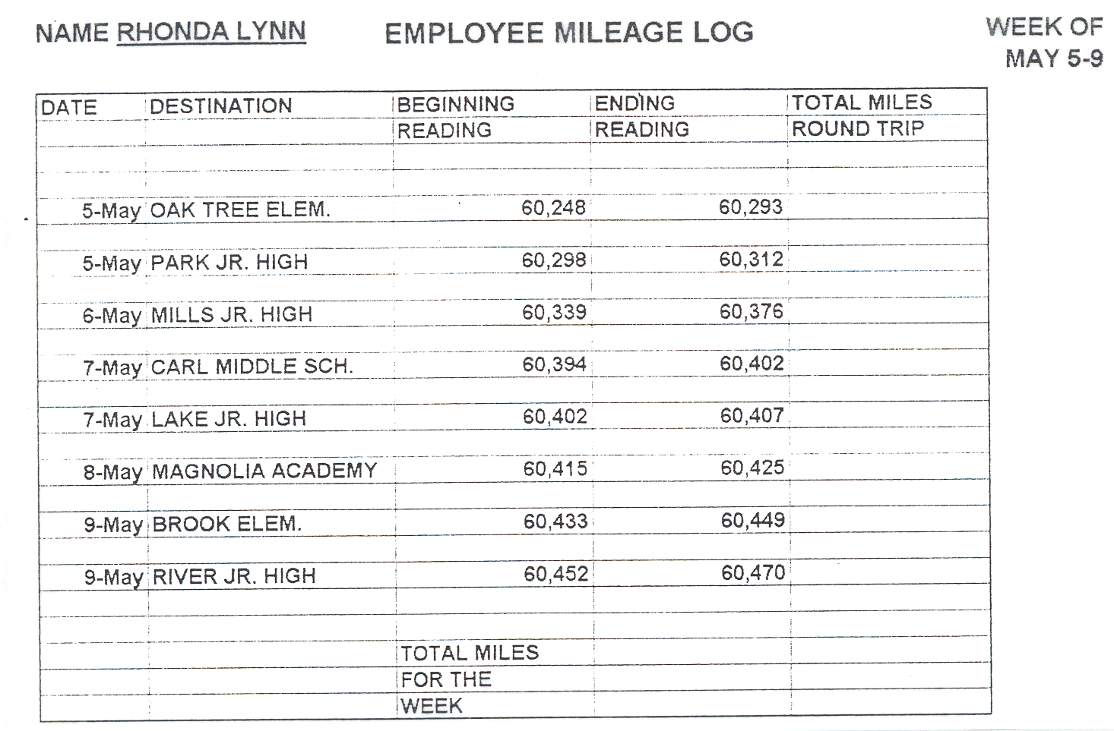
Completing a Mileage Log

Group Names ___________________________________________________
Date _________________

Group Work for Competency M18
You are the assistant to the plant maintenance engineer at United Dairy Farmers. You are responsible for testing the water supply pressure at certain points. If the water pressure is not within a certain range, the system is not working properly and you need to report it to the engineer.
Complete the checklist in the chart below. Record the gauge reading for points A to C. Check if each pressure reading falls within the acceptable range by putting a check mark (√) under yes or no.

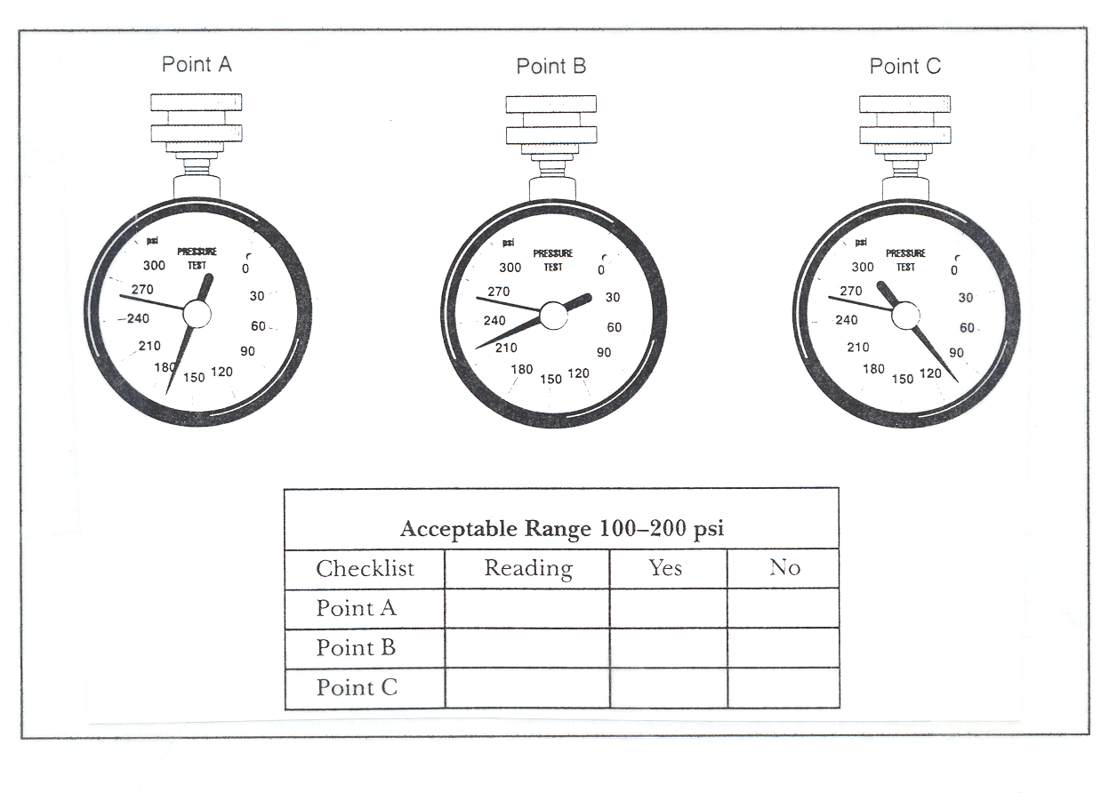

Name ___________________________________ Date __________________

Assessment for Competency M18

1. List five units each for measuring:
time: _____________________________________________________________________
weight: ___________________________________________________________________
distance: _________________________________________________________________
volume: __________________________________________________________________

2. Give an example of when you would use an odometer.
__________________________________________________________________________________________________________________________________________________

3. Give an example of when time and distance are used together.
__________________________________________________________________________________________________________________________________________________

4. Read the measurements for packages A, B, C, D, E. Use the amounts to fill out the weight column of the shipping log.

WES Math, p. 111

WES Math, p. 111

